Write-up of Findings for Layar Twitter
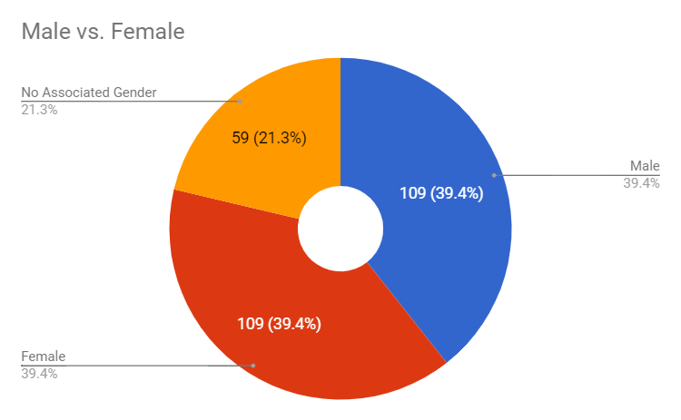
The Layar twitter data collected throughout the entire semester provided some intriguing and notable findings which can lead to further study and research for the future of Ar and how this application works in the world around us. Information ranging from time of the tweet, location tags, social media elements, gender of the tweeter, and other various information referenced in the tweet were all various factors considered and coded for the research of this AR application. Of all the data collected, some factors stood out as significantly more notable than others; for example, factors such as “Illegal Activity”, “Annoyance”, and “Weather” were only apparent in five or less than the 277 tweets total, while factors such as “Positive Emotion” and “Hashtag/Emoji” had over 100 instances of the 277 tweets. This large difference between different factors can be very indicative of how social media is used and what kind of social media users may be geared toward using as AR application alongside social media such as the geotagging feature incorporated on twitter which is utilized by the Layar app.
Figure 1: Male vs. Female Association on Twitter
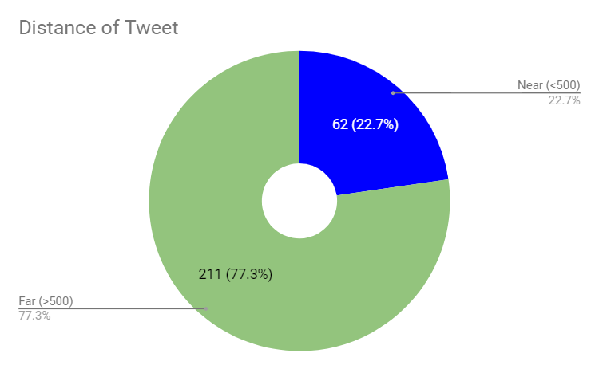
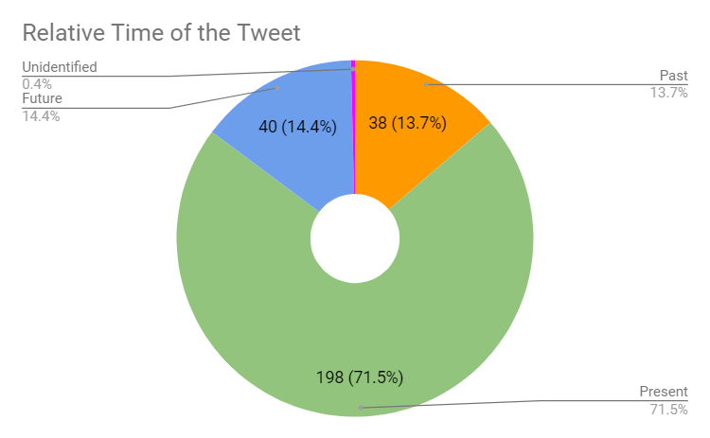
Shown above is a figure of the ratio of male to female to total of the tweets metricized over the period collected. As you can see, the amount of both female and male tweeters is at and even number of 109 each, with then 59 tweets being either non-associated with a gender or unidentifiable from the given information. This information displays that both female and male subjects are using the geotagging feature of social media very evenly between both, and that there is a notable 21.3% of businesses/non-identifying people using the application as well.
Figure 2: Chart of Distance of Tweet
Figure 3: Relative time of the tweet
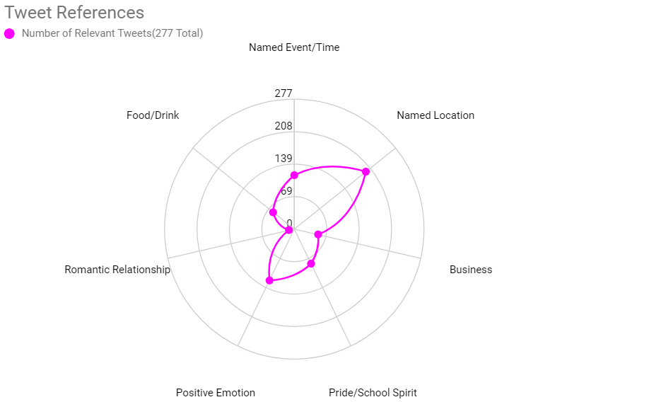
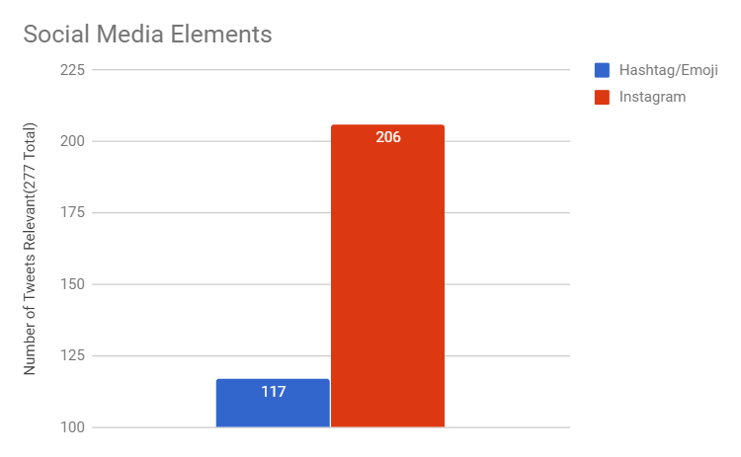
Figure 2 above displays the relative timing of the tweets separated into “past”, “present” and “Future”. 14.4% of the tweets were recorded as being in the future, 13.7% of the tweets were recorded as being in the past, and 71.5% of the tweets were recorded as being in the present. This data is significant in showing that most people tweeting using this geotagging feature are tweeting about events or situations currently happening in their lives, and an even amount of users are using social media to present past or future content. Figure 3 shows the comparison of distances of the tweet from the area where the tweets were seen and recorded on the geotagging Layar app. 62 tweets were marked as “near” or being less than 500 meters away, and 211 tweets were marked as being “far” or greater than 500 meters away. This data proves that although all of the tweets were being collected in the swift building location very close to the center of campus, the majority, or 77.3%, of the tweets were actually tweeted from a distance radius of about 0.31 miles, which would mostly be in the areas surrounding the edge of campus. This data makes sense since most dorms, housing, and any restaurants, bars, or social gathering areas are surrounding the edge of campus, meaning that the majority of people tweeting this information are doing it in their home or out socially rather than on campus.
Figure 5: References/content in the tweets
Figure 4: Social Media Elements used in tweets
Figure 4 above compares the uses of different social media elements in the tweet including hashtags/emojis and if the tweet has an Instagram link, meaning it was shared on Instagram in addition to twitter. 206 of the 277 tweets were linked to Instagram; this data shows that the majority of the geotagging is occurring with instagram users with their post linked to twitter. Over twitter, Instagram is a more location focused app, as one of its min features including tagging a location. While twitter has this option as well, it is more prevalent in Instagram as the pictures of Instagram prompt more of a use of location over a tweet that may not be relevant to a location. 117 of the 277 tweets included a hastag or emoji in the tweet; hashtags can be used for fun or for to get more attention if the hashtag is trending. This shows that the users of this geotagging feature could be seeking greater promotion of their social media content, and more research could be conducted to explore and test that question. Figure 5 above shows an array of different content referenced in the tweet. With “Named Location” and “Positive Emotion” being the highest volume of tweets, this emphasizes the use of social media users presenting their location as a sense of self promotion. Positive emotion possibly reveals the personality of social media as being one that displays the best version of one self to attract the most attention; positivity tends to be more appealing to the masses and tends to attract the most positive attention as well, which is why tweeters may be outwardly presenting this factor in their tweets.
Overall, the tweets recorded over this semester through the Layar application reveal many various possibilities about the people using the social media and geotagging feature, and possible correlations between the two.

Individual Research
Throughout the course of the semester, various surveys and experiments regarding AR have been explored and read to further the current understanding, application, and research which is being conducted in the AR community to this day. Users, industry, devices, and law/government are key fields in which AR currently plays or is foreseen to play a major role in the shaping and development of how AR will be integrated into society. Along with these different fields comes opportunities for research and the ability to explore research questions associated with those different fields.
One possible research question could be “What are common associated characteristics with consumers interested or invested in using augmented reality devices?” This research study could prove to be especially important for a wide variety of reasons; marketing, hardware and software programming, and availability/pricing are all affected by the types of users AR attracts.
Audience is one of the most important things to consider when considering product development. Research into this area of study would prove incredibly beneficial to all aspects of the development of AR applications in the future as it would shape the entire prospect of the technology.
Another research question which would be interesting to explore would be “How do augmented reality applications affect reality and psychosomatic perception, and what are the possible mental health effects it could have on a user?” As with any new technology, especially one introducing more exposure to up and coming technology, it is incredibly important to study the possible impact the technology will cause its users, and one major impact technology has on users is mental health and reality perceptions. How AR devise affect the way the world is physically and virtually perceived, along with any mental health benefits or detriments would be the key focus of the study. AR has the likelihood of strongly affecting the way the world is viewed on a daily basis in the future and research is key in ensure the safest and most beneficial future for the people and environment.
A third research question to possibly explore would be “Which types of people adapt the quickest to using augmented reality technology? Additionally, how quickly do they adapt, and do they adapt to different types of AR technologies quicker than others?” This research question would be particularly beneficial to hardware and software developers of AR since it will shape how they create their products, which products work best, and areas they need to improve with accessibility of the technology.
Another research question of interest would be “How does the use of augmented reality applications impact face-to-face communication between people?” Like the previous research question, it is important to look at the lasting affect AR could have on society. An increasing concern with more and more technological advances is the decrease in social and intrapersonal skills of users. It will be important for developers to not create products which are so isolating, otherwise they will be harder to market to consumers and will eventually cause major issues in humanity.
A fifth research question to potentially explore would be “How do users respond to different levels of augmented reality exposure, especially over multiple devices with a possibility of unlimited data access?” Going along with the second research question proposed on reality perception, this focused on the mental impact of AR technologies and how the user interacts and reacts to different applications, prototypes, and designs. This is relevant in that it greatly effects the software design of AR as well as how it can apply to different fields such as healthcare/medicine, education, media/entertainment, and enterprise/industry.
Many research questions that can be explored of AR will serve to aid the development, marketing, societal impact, and health implications coinciding the adoption of this new idea and technology into the future world.

Annotated Bibliography
Research question of interest: “Which types of people adapt the quickest to using augmented reality technology? Additionally, how quickly do they adapt, and do they adapt to different types of AR technologies quicker than others?”
Adams, Dennis A., R. Ryan Nelson, and Peter A. Todd. "Perceived usefulness, ease of use, and usage of information technology: A replication." MIS quarterly (1992): 227-247.
Written years back in 1992, this study explores not the applications or ease of use of AR, the adoption and patterns of perceived usefulness and perceived ease of use of technology. The study used these two variables to develop a test for content validity, reliability, and construct validity. The study found that perceived usefulness and perceived ease of use were significantly correlated with self-reported current usage and self-predicted future usage. Usefulness had a significantly greater correlation with usage behavior than ease of use did. This study is important to the chosen research questions because it draws on past patterns of how people perceive and adopt new technologies, which is key to predict and try to improve how AR would be adopted.
Balog, Alexandru, and Costin Pribeanu. "The role of perceived enjoyment in the students’ acceptance of an augmented reality teaching platform: A structural equation modelling approach." Studies in Informatics and Control 19.3 (2010): 319-330.
This study focuses on the affect augmented reality applications has on a user’s motivation in the education fields when looking at student’s interests and engagement in the learning process. It directly studies the perceived enjoyment as well as perceived usefulness and ease of use of the students’ acceptance of an AR teaching platform since motivation levels have proven to have direct correlation to success. The study found that both perceived usefulness and enjoyment have a significant impact on the behavioral intention of using the AR application, while perceived ease of use is not a significant factor. This study is relevant because it exposes the application of students using AR and how they may adapt and react to the application.
Due, B. L. (2014). The future of smart glasses: An essay about challenges and possibilities with smart glasses. Working papers on interaction and communication, 1(2), 1–21 (University of Copenhagen).
This study delves into the possible affect that an AR application such as “smart glasses” as wearable technology—like google glass or even hololens—could have on society. It focuses on the challenges and issues that could arise due to wearable AR technology in different fields such as product category, eye issues, privacy issues, technology development, historical, sociological issues, and interracial and psychological issues, with the most important part of the study including challenges with acceptance. The study showed that in the past there has always been challenges of social norms when new technology is being introduced. This study is relevant to the research question in that it states a new “social etiquette” for the use of smart glasses needs to be established and defined, which could apply to the adoption and acceptance of any new AR technologies yet to come.
Van Krevelen, D. W. F., and Ronald Poelman. "A survey of augmented reality technologies, applications and limitations." International journal of virtual reality 9.2 (2010): 1.
This study surveys the state of the AR field of technology by reviewing recent applications of AR technology as well as a number of known limitations regarding human factors in the use of AR systems that developers will need to overcome. This study will prove beneficial and relevant for the human ability to adopt and adapt to the technology so developers can foresee possible issues and work to fix them to create the most widely useable product.

Study Proposal
The research question which is to be explore is “Which types of people adapt the quickest to using augmented reality technology? Additionally, how quickly do they adapt, and do they adapt to different types of AR technologies quicker than others?” As shown in the previous section, there are various studies which have been conducted in regard to the perceived ease of use, perceived usefulness, adoption of AR teaching methods, perceived challenges with wearable technologies, and the overall limitations of AR technologies due to human factors. These studies will all prove beneficial in aiding the research question as they pertain to how people adapt and use new technology, specifically relating to AR, however more research will need to be conducted in order to fully explore the question at hand.
A predicted hypothesis for the research study would be “Younger consumers and users would adapt quickest to the use of AR technologies compared to adults over the age of forty”. This hypothesis would be an educated proposal based off of past studies showing the adoption of technologies to different age groups, which showed that younger generations/users who are exposed to technology at younger ages than older generations adapt and learn new technologies quicker than those older than them. It would also be important to include other demographical groups aside from age in the mix, such as country, socioeconomic class, or even gender. Culture/county of origin would also be important. Users in the United States, China, Japan, and Europe are more exposed to the luxuries of technology than those users in developing countries, what affect would this have on the adaptability of users who have been exposed to less technology but may be in the same age group?
Assuming the resources were unlimited, this study would require extensive access to people from all over the country and world. Ideally, different studies would be conducted such as an age group study, country of origin study, socioeconomic study, an ability study, and a gender study. A wide variety of prototypes of different AR technologies would need to be used for each different experiment, with all experiments using the same technologies to keep that variable controlled so there is no error is ease of use for one product being greater than that of another product. The technology being used would be a wide variety of different products which test the different capabilities of human factors. Wearable eyewear/headsets of AR, handheld applications for AR, and heads-up displays would be the different categories of technologies used in the experiment. For each different experiment group as well, it would explore the applications in different fields such as media/entertainment, education, enterprise/industry, and healthcare, with each experiment group exploring all of these different fields.
For the age group study, multiple users in each age range of 10 years from 0-100 years would be collected and tested together; for example, ages 50-60 years would be tested, along with ages 10-20 years. This allows for the most widespread and accurate data. Country of origin and socioeconomic variable would need to be constant for a control purposes, while gender and ability would be evenly spread throughout to negate any uneven systematic error in the experiment.
For the country of origin study, multiple users from around the world of the same 10 year age range would be collected to conduct the adoptability of AR. Age as well as socioeconomic status would need to be controlled for error purposes, as a 12 year old from china could have an adaptability advantage over a 40 year old from England due to age more so than the reason being country of origin. Gender and ability would need to be evenly distributed throughout as well, ensuring a control.
For the socioeconomic study, similar to the other studies the other factors need to be controlled. Country of origin, gender, age, and ability would all either need to be held constant or evenly controlled throughout the experiment. The gender study would also require all other factors to be controlled and constant or evenly distributed, meant to test in difference of adaptabilities between male, female, and other identifying genders.
The fifth study, ability, is arguably the most interesting and important. Holding all other variables constant per usual, this study would explore the adaptability of AR for a variety of people with physical and mental disabilities such as seeing and hearing impaired, non-able bodied, learning disabilities, and any people with mental implications such as bipolar disorder, dissociative identify disorder, or schizophrenia. These studies are so important because such a notable part of the population is physically or mentally impaired, and their ability to adopt, not adopt, and adapt to AR technologies and a possible future filled with AR is crucial to make sure the world is still accessible to them. This part of the study would require more need of resources as it would need additional medical and psychological doctors or therapists to be able to assist users with any possible issues and interpret. Medical staff, hardware and software developers, IT technologists, developmental and psychological researchers, and market researchers would all need to be staffed and present throughout all the experimental studies to provide a wide range of background, understanding, and thought to the research team.
There are many, many other factors that can be explored when studying the adaptability and how AR is projected to be accepted and adopted into society in the near future, and we have a long way to go with research to get these questions answered.

